pROFESSOR Nazar A.Majeed RAsheed Albarwari
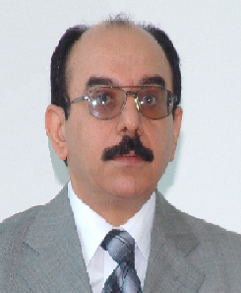

pERSONAL iNFORMATION
Address |  | Flat No. 23, Road No. 3933, Block No. 939, Build No: 1502 Alriffa-Alhajiyat.Kingdom of Bahrain
mobile |  | 00973 36771377
e-mail |  | nbarwari66@hotmail.com , prof.nazar.albarwari@gulfuniversity.net
date of bIrth |  | 5th/Feb/1954
Nationality |  | IRAQI
career profile |  |  | An individual with strong academic and professional experience. Professor in teaching marketing topics and quality concepts, to MBA and MSc. Students. In addition, to providing training sessions to practitioners and facilitating successful transition to contemporary marketing & quality management trends needed in current dynamic environment.  Over 29 years of wide ranging professional experience in Higher Education  (Teaching, Research, Consulting) in different Educational Systems (Iraq, Yemen, Bahrain)
Work Experience  1983-1988  1988 - 1992  1992- 1999  1999- 2003  Oct 2001-Feb 2002  2003 - 2005  1984-1987  1990-1992  1997-1999  1999 -2001  2000-2001  2000 -2001  2005-2009  2009 – TO date  Feb 2012 – May 2013  2013- tO date  OCT 2013-to date  Dec2013- to date |  |  | Al-Mustansiriyha University, Baghdad, Iraq, Faculty of Administration and Economics,( Scientific& Academic Record)  Assistant Lecturer in, Department of Business Administration  Lecturer In Above Mentioned Faculty & Department  Associate Professor In Above Mentioned Faculty & Department  Professor In Above Mentioned Faculty & Department  Visiting Professor, University of Eden, Republic of Yemen.  Professor, University of Ibb, Faculty of Commerce, Yemen. Republic of Yemen  Al-Mustansiriyha University, Baghdad, Iraq, Faculty of Administration and Economics(Administrative Tasks Record)  Coordinator of Business Administration Department in above mentioned Faculty.  Member of consultancy office in above mentioned Faculty.  Secretary of the board of the Faculty of Administration and Economics  Head of Business Administration Department in above mentioned Faculty.  Head of scientific promotion committee, Faculty of Administration & Economics ,Al-Mustansiriyah University  Member of the Al-Mustansiriyah University scientific promotions central committee.  DELMON UNIVERSITY FOR SCIENCE& TECHNOLOGY- BHRAIN  Director of Training & Consultancy Centre.  Professor of Marketing. Faculty of Administrative& Financial Science.  Member of post graduate studies& scientific research board.  GULF UNIVERSITY – BAHRAIN  Professor of Marketing, College of Administrative Financial Sciences  Member of University Quality Assurance Committee.  Member Of gulf university Journal editorial board
Scientific promotion |  |  | - Promotion to Lecturer (equal Assistant professor) in June 1988.  - Promotion to Assistant professor (equal Associated professor) in June 1992.  - Promotion to Professor rank in April1999.
Selectedtraining& Workshops certification  April 2006  November 2006  May 2007  June 2007  May 2008  November 2008  March 2014  January 2014  April 2014  May 2014 |  |  | Workshop titled “Quality Management Training ISO 10015”, hosted by Specific Council for Vocational Training in Industry (SCVTI) in association with Academy for Quality & Training education ( AdeQua T& E)  Bahrain Productivity Conference and Improving Small Business Project Performance, hosted by Economic Development Board (EDB).  Conflict Resolution Workshop hosted by Huron University, London & RTC (Responding to Conflict) The Workshop was Facilitated by Professor Dr. Bruce Stanley.  Workshop on Quality Assurance & Self – Evaluation in Higher Education. The Workshop was Facilitated by Professor Dr. Colleen Listen & Organized by the Australian University Quality Agency (AUQA).  Workshop titled” Course plan design, Teaching techniques and Exams Evaluation”, hosted by Delmon University for Science and Technology in Association with Al-Yarmouk University, Jordan,.  Participating as expert and main speaker in symposium titled “Strategic Planning for Arab Organizations and its role in the 21 century”, Organized by Arab administrative development organization (Arado) in Lebanon, for the period 18 – 20, November 2008  Workshop titled ‘Effective Use of Technology in Higher Education’, Facilited by professor Beverley Leeds, hosted by British Council, 18-19 March, 2014.  Professional Training program titled” Social Responsibility Specialist”, Delivered by professor Ali Al Ibrahim, Organized by Social responsibility regional network.  MENAPAR Conference "Middle East, North Africa Public Administration “, held by BIPPA- Bahrain in Association with IIAA, UNDP of Bahrain.23-24, 2014.  International Leadership conference “Leadership ......New Horizons 2014”, held by Bahrain Management society. Kingdom of Bahrain
Publications  1984- 2013  1990 – 2013  Assessor for Scientific Promotions Schemes  Examining Boards  Taught Courses  Consultancy & Training Work  Scientific  Conferences  Post Graduate Theses Supervision  1996 - To date |  |  | - Research Experience  Presented in different local& Arabic and international scientific journals& conferences. As follow:  1 - Modem Trends in preparing Managerial Budgets, Management & Economy Journal, Al-Mustansriyah University, No, (7).Iraq.1985.  2 - Organizational Environment as an Indicator to the effectiveness of Warehouse Management, Published in 6th Conference of Management & Economy Faculty proceedings’ , Al-Mustansriyah University, Iraq.1986.  3 - Product Development and Planning: Applied Study in the Light Industries. Company, Published in 7th Conference of Management & Economy Faculty proceedings’, Al-Mustansriyah University, Iraq.1989.  4 - After Sale Services: Applied Study in the Company of Automobiles Trade, Management & Economy Journal, Al-Mustansriyah University, No, (11).Iraq.1990.  5 - Employees Performance Evaluation: Applied Study in the Men's clothing company, Iraq. Management & Economy Journal, Al-Mustansriyah University, No, (13).Iraq.1991.  6 - Motivation and Incentives: Comparative Study between Modern Management and Islamic Thoughts, Management & Economy Journal, Al-Mustansriyah University, No, (23).Iraq.1998.  7 - Use of cause – Effect Chart in Analyzing Causes of Internal Rejects: Applied Study, published Arab Conference of Planning& Managerial development proceedings’. November. baghadad.Iraq, 1998.  8 - Reengineering as an Approach to Organization Excellency, Management & Economy Journal ,Al-Mustansriyah University, February, No, (28).Iraq.1999.  9 - The Application of Quality Management System (ISO 9001) in the Mechanical Carpets Factory, Alhadbaha University Journal.Mosal,IraqNo, (1),2000.  10 – Requirements of TQM and its’ applications in Iraqi Organizations: Future – oriented, Al Mansour University Journal, No, (1), Baghdad, Iraq, 2000.  11 - Bench Marking: An Approach to Continuous Improvement to Organization, National Journal of Managerial Sciences, No, (1), Baghdad, Iraq, 2001.  12 - The Role of Arabic intellectual capita1 in the emerging society of Knowledge and Competitiveness, Management & Economy Journal, Al-Mustansriyah University, No,(36).Iraq.2001.  13 - Consumer Protection in the Health Sector: A Study in a Sample of Hospitals in Baghdad, Alqadisiha Journal, Alqadisiha University, No,(4), No(4), Iraq. 2001.  14 - Management in Islam, Islamic Thinker Journal, Global Islamic Conference Organization, 2002.  15 - Control Planning: Modern Management and Accounting Approach, Management & Economy Journal, Al-Mustansriyah University, No, (41).Iraq.2002.  16 - The Influence of Continuous Improvement Techniques on Organizational Performance, Alqadisiha Journal, Alqadisiha University, No, (4), No(6),2002.  17 - Designing and Introducing Service, its Relation to the Quality of Hospitality: Applied Study, University researcher Journal , University of Ibb, Republic of Yemen , No,(7),2003.  18- The impact of benchmarking on organizational performance, Case study in Modern Painting company, Industrial Cooperation Journal, No, (95), Qatar, 2005.  19 - The impact of Continuous Improvement techniques on organizational performance : Conceptual framework with applicable indicators for industrial organizations, Managerial Science Journal, University of Aden, Republic of Yemen, No,(1), 2008.  20 - Contemporary Educational Management Models & Total quality Management requirements: Comparative study. Arab Journal for Quality Assurance in Higher Education, No, (3), 2009. WWW.UST.EDU/UAQE.  21 - Integration role of community institutions of instilling the values of education, citizenship and prosperity for all. Electronic Journal of Alum Insania, seventh year, No, (46), summer, Holland, 2010. WWW.ULUM.NL.  22 - Opportunities and threats facing the Arab companies in international markets and its relationship to export performance: philosophical knowledge framework. Published in Averroes University Journal. NO, (5). March, Holland, 2012.  Books  6 books published in Marketing, Quality. Scientific research methods fields. As follow:  1 - Quantitative Techniques In Management,( 1990), Publication Consolidation by Al mustansiriha University,Dar Alhikma for publication& distribution,Dar of Books and Documents, (1764), Baghdad, Iraq.  2 - Marketing strategies,( 2004, Republished in 2008 ) ,Dar Wael for publication, Amman, Jordon. ISBN 9957- 11 – 485 – 9.  3 - Marketing Management In Non for profit Organizations,(2009), Dar Alhamed for publication. Amman, Jordan, ISBN 978 – 9957 – 32 – 386 – 8.  4 - Scientific Research: Concepts, Techniques and Applications,(2011), Al – Waraq for publication& distribution, Amman, Jordon, ISBN 978 – 9957 – 33 – 139 – 1.  5 - Quality Management: Excellence & Leadership Approach,(2012), Al – Waraq for publication& distribution, Amman, Jordon, ISBN 978 – 9957 – 33 – 216 – 7.  6 - Institutional Excellence: Quality and Best Practices Approach, Principles & Applications,(2013), Al – Waraq for publication& distribution, Amman, Jordon, ISBN 978 – 9957 – 33 – 301 – 0.7- Knowledge-based marketing: Excellence Marketing performance Approach,  7- Al – Waraq for publication& distribution, Amman, Jordon, ISBN 978 –33 –339-3.  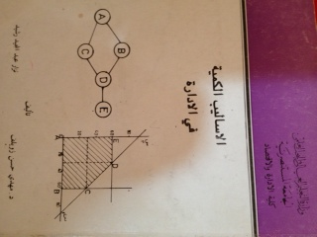  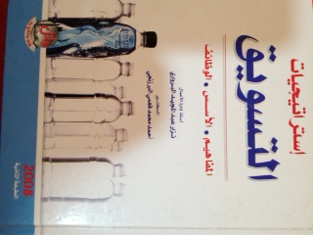  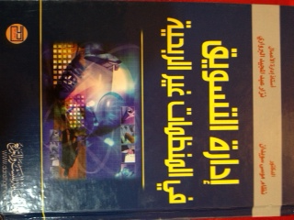  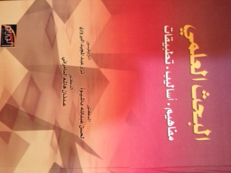  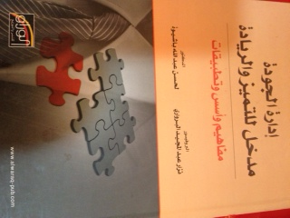  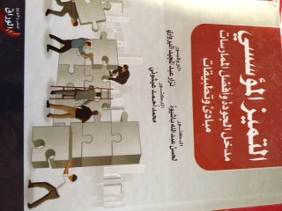  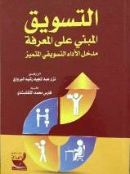  - (12) Scientific promotions for lecturer Rank.  - (12) Scientific promotions for Associate professor Rank.  - (8) Scientific promotions for professor Rank.  - MBA degree: (34) Theses. As ( Session member& chairman)  - PhD degree: (11) Theses. As ( Session member& chairman)  Since 1983 to date, I have been teaching the following courses:  A. B.Sc  Marketing Principles, Marketing Management, Marketing Researches, International Marketing, Consumer Protection, Advance Studies in marketing, Service Marketing, Marketing Communication. Contemporary Business Administration, Production operations Management, Strategic Management, Quantities techniques in management, H.R. Management, Operations Researches, Purchasing /Warehousing Management, Principle of Business Administration, Organizational Behavior, Management Information Systems, Financial & Banking Terminologies, English for Business, Scientific Research Methods.  B. MBA  Marketing Management, Operations Researches, quantitative techniques, Production Operations management, Human Resources Management (HRM), Organization Theory, Scientific Research techniques, and Quality Assurance: Concepts & Systems.  C. PhD  - Production Operations Management.  - Seminar.  - Member of the Consultancy Office in the Faculty of Administration and Economics 1990 – 1992, Al-Mustansiriha University, Baghdad, Iraq.  - Consultant in the Electricity Board, Iraq, 2003.  - Consultant in the Ministry of Planning, Iraq, 1999 – 2002.  - Consultant in the Science and Technology Board, Iraq, 1999- 2003.  - Design & delivery of over (100) training Courses on quality Management, Total quality Management, Marketing management, HRM, & related topics for different managerial level and issues.  - Training & Consultancy Centre Manager, Delmon University for Science &Technology, Bahrain 2005 - 2009.  - Consultant, Social Responsibility Regional Network, Bahrain, 2013 to date..  A) Locally  - (6) Conferences, Faculty of Administration and Economics, Baghdad, Iraq (1984 – 1998). (presented a paper in each conference).  - Conference of TQM Applications / central commission of standardization and quality control Baghdad, Iraq. 1999,(presented a paper).  - Conference of Arab federation of scientific Research Banking industry: future vision / Baghdad, Iraq, 2000 (Session chairman).  - Sixth scientific conference of Al-Mansuor University, Baghdad, Iraq, 2002, (Session chairman).  B) Arab Region  - Al-Yarmook University, conference / Jordan (July 2000), (presented a paper).  - Al-Zaytoona University, conference / Jordan (April 2002), (presented a paper).  Jar ash University conference / Jordan (June2002) (presented a paper).  - Applied Sciences University, conference / Jordan (July 2003). (Presented two papers).  - Taiz University conference / Yemen (May2005), (presented a paper).  - Delmon university symposium, Manama, Oct 2007, (Presented a Paper).  - Delmon university symposium, Manama, April 2008, (Symposium chairman).  - Third Arab administrative Development Organization Conference. Egypt, Jan 2010, (Presented a Paper).  - (12) Master theses in the (Marketing, Quality.HRM) fields.  - (3) PhD theses in the (Marketing, Quality) fields.
  Theses title | Degree | Minor field | date
  Utilization of cause – Effect Chart in Analyzing Causes of Internal Rejects: Applied Study | MBA | Quality Management | April 1996
  Analytical study of the preferences of a sample of personal computer users using multiple characteristics models | MBA | Marketing Management | January 1997
  Evaluation of quality circles building: An empirical study in factories of Jordan cement companies | MBA | Quality Management | December 1998
  Impact of applying ISO 9002 system upon performance: Explorative in a sample of Jordanian organizations | MBA | Quality Management | November 1999
  Quality management systems: ISO 9001:case study in Mechanical Carpets factory-Iraq | MBA | Quality Management | December 1999
  An analytical study of factors affecting the determination of optimal production mix in cotton textile factory in Diwaniya- Iraq | MBA | Production Operations Management | December 1999
  Impact of Total quality Management on consumer protection: an Empirical study | MBA | Quality Management | December 2000
  Identify features and trends in the Iraqi school of management : lessons derived from the campaign of reconstruction project | MBA | Production Operations Management | January 2001
  Factors affecting marketing information strategy: Applied study in a sample of Iraqi media organizations | PhD | Marketing Management | June 2001
  Determinants of the design and selection of distribution channels and their impact on performance: An empirical study | MBA | Marketing Management | August 2001
  Analysis of the marketing opportunities and limitations for the trade – off between local and international markets: An analytical study of the views of a sample of managers of Yemeni industrial companies | PhD | Marketing Management | October 2001
  Analyze the quality of hospitality services: an empirical study in a sample of Baghdad five stars hotels | MBA | Quality Management | January 2002
  Impact of applying ISO 9002 on operational performance: A case study in Kufa Cement plant | MBA | Quality Management | January 2002
  Impact of benchmarking on competitive advantage: A case study in modern company of painting | PhD | Quality Management | September 2002
  Creativity in the administrative applications: A case study of an Iraqi organization | MBA | Quality Management | April 2003
languages  ARABIC  ENGILSH  Kurdish  Membership of Professional Bodies  REFERENCES |  |  | - Fluent, Speak & write.  - Very good, Speak & write.  - Fluent, Speak.  - Member of Iraqi Economists Association, 1976.  - Member of Iraqi Accountants and Auditors, 1987.  - Member of Iraqi teachers union, 1987.  - Member of Arab Knowledge and Management, Society (AKMS), Jordan, 2005.  - Member of Bahrain Quality Society. Bahrain,2009.  - Member of Editorial Board of Arab Journal for quality & best practices and excellence.  (Ajqbpe). 2012.  Prof.Dr. Mohamed AICHOUNI, The Mechanical Engineering Department, College, Engineering, Hail University, Saudi Arabia. m_aichouni@yahoo.co.uk.  Prof.Dr. Shawqi jawad, The head of Business Administrative department, Amman Arab University, Jordan, shawkijawad@yahoo.com.  Prof. Dr. Muthana Al-Hurry, Al-Zaytoona University, Chair of Tourism Management, Amman-Jordan. malhoory@yahoo.com.  Prof. Dr. Jamal.d. Salman, Dean of Business Administration Faculty, Applied Sciences University, Muscat, Oman. Jdawood26@yahoo.com  Prof. Dr. Amer Macdesy, Dean of Business Administration Faculty. Averroes university, Amsterdam-Netherlands. haikalgrc@yahoo.com.  Prod. Dr. Ali Mansour bin safa, University of Aden, Faculty of Managerial Sciences, Currently: The Ambassador of Yemen in Kingdom of Bahrain. binsafa@gmail.com.  Prof. Dr. Moaid Abdul Rahman al doori. Dean of post graduate studies, Amman Alahlia university. Amman, Jordan. md_aldoori@yahoo.com.  Prof. Dr. Tariq Sharif Younis. Dean of Business Administration Faculty, Applied Sciences university. Kingdom of Bahrain, Manama. Tariq522002@yahoo.com.  Prof. Dr. Sharif El araby. Vice president of Delmon Academy for computer and Managerial Science. Kingdom of Bahrain, Manama. sh.elaraby@gmail.com.

